Load Testing – Http/S protocol – Westpac.co.nz – home page Explanatory Document

Tested URL : <https://www.westpac.co.nz/>

Number of users : 50

Rampup Time : 15 sec

Tested Scenario : Loading the Home page with and without load(1 user)

The load generator used is the local machine so test can be done only for 50 users.

Here are the steps for installation and execution for the jmeter script ( attached here)

Step 1 :  Install selenium webdriver plugin

Step 2 : download Chrome driver

Step 3 : Assuming you have jmeter already downloaded. ( navigate to the path )

Step 4 : Execute the jmeter in non GUI mode and provide the params (files and folder paths and threads and rampup

Jmx file :

1. Add chrome Driver config  on test plan level
2. Create two thread groups (one for without load and another for with load)
3. Add one Webdriver sample for each thread group
4. Both needs to run one after another ( there is a checkbox on the test plan to run thread groups one after another )
   1. one with 1 users with 1 sec ramp to check the system response without load
   2. Another one with 50 users with 15sec rampup ( these parameters are passed from command line)
5. Parameters used
   1. Url - in user defined variables to pass the url
   2. threads & rampup are used to pass the required load to the script from command line
6. JTL and Html report location to be passed in the command line

Execution - Run the following command for command line

C:\Users\${username}\Downloads\apache-jmeter-5.4.3\apache-jmeter-5.4.3\bin\jmeter -n -t C:\Users\${username}\Downloads\uiloadtest.jmx -Jthreads=150 -Jrampup=15 -Jurl=<https://www.westpac.co.nz/> -f -l  C:\Users\${username}\Downloads\UILoadTest\result.jtl -e -o C:\Users\${username}\Downloads\UILoadTest\Htmlreport

Result”:

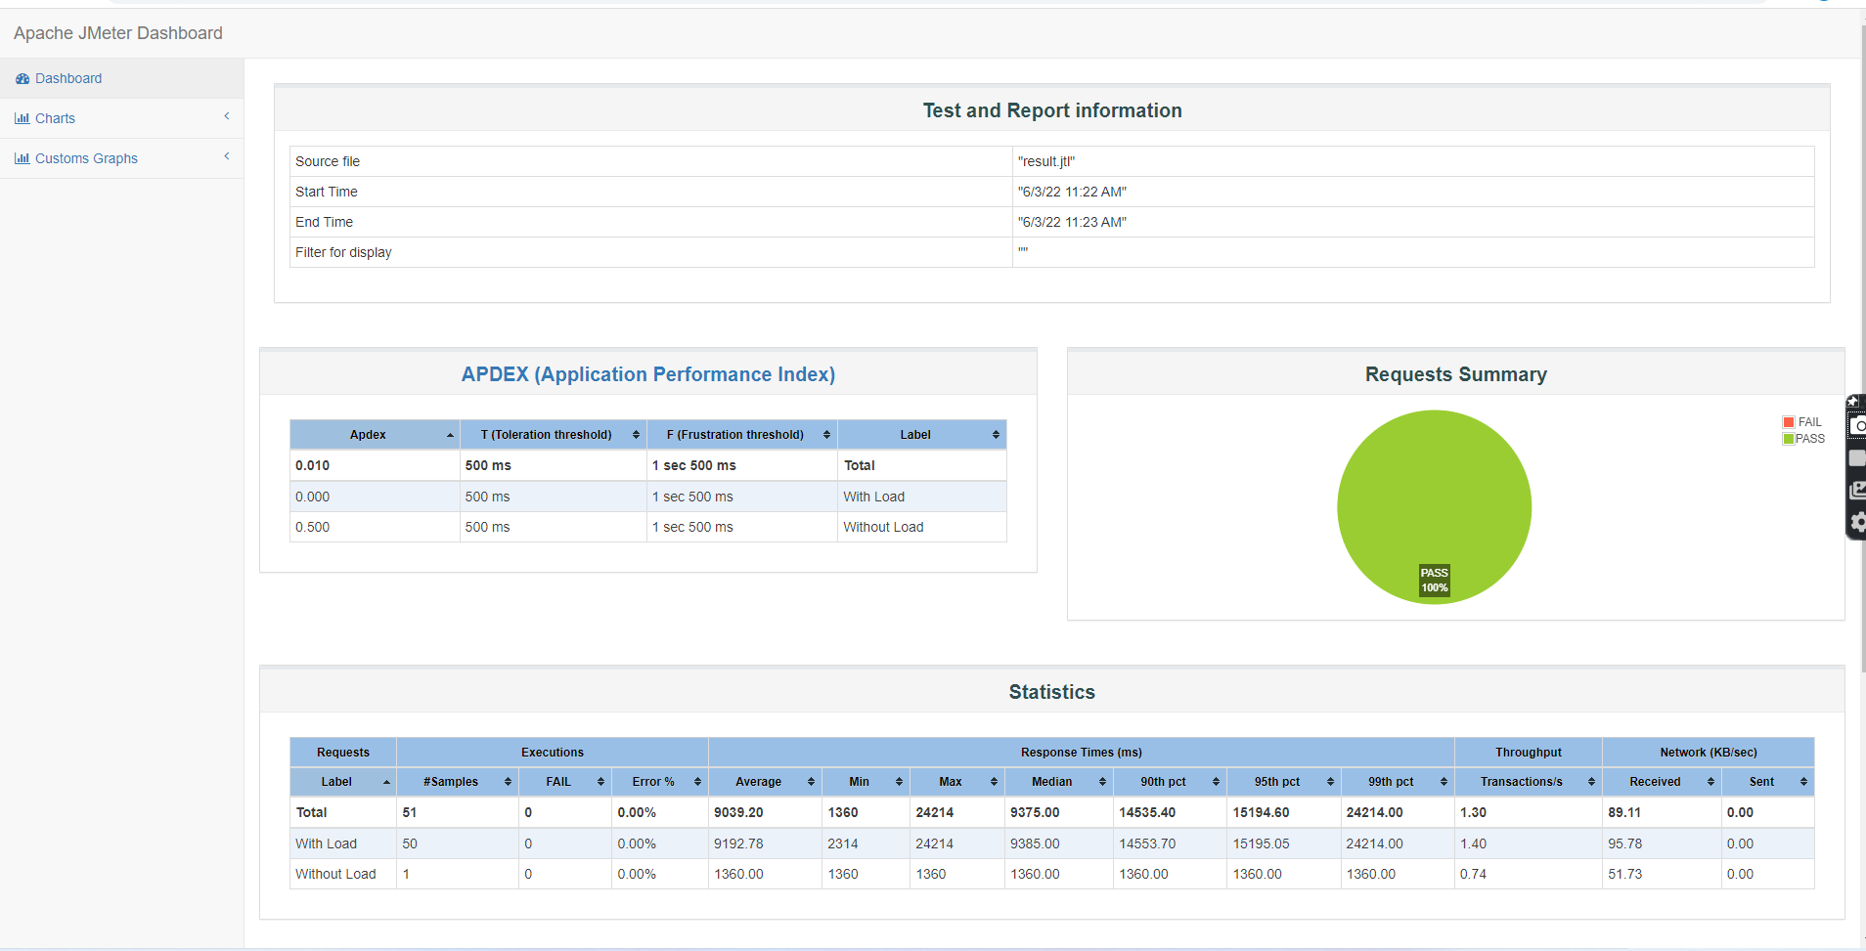

The application response time is measured at 95th pct

For 50 user – the application loads at 15 sec which is not accepted.

The data transfer is good compared to one user and 50 user which is 1:2 ratio.

Overall the application needs to be optimized.

Application response time is directly measured using the load test

The average response time for modern application is considered as 2 sec (but it varies depends on may factor. Ie what are the attributes that are loaded)